**DOCKER**

**Docker**

* Docker is one of the tools that used the idea of the isolated resources to create a container that allows applications to be packaged with all the dependencies installed and ran wherever we wanted.
* Docker can only run on Linux machines this means I cant install Docker directly on Windows or any other OS.
* If I want install Docker on windows then I need to run a Linux VM in windows on top that I need to run Docker.

**Virtualization (VM)**

* VM is way of running virtual OS on top a host OS using a special software called Hypervisor.
* VM directly shares the hardware of the host OS.

|  |  |
| --- | --- |
| Virtualization at hardware level | Virtualization at OS level |
| Heavyweight - consume more host resources | Lightweight |
| VM uses hypervisor | containerisation tool is used |
| limited performance - Boot up time is more which is in minutes | Native performance - usually boot fast in seconds. |
| Consumes more storage | Shares OS storage means only uses required storage. |
| Supports all OS | Supports on Linux |

**VM                                                            Containerisation**

**host machine**  
    This is the machine in which docker is running **Docker image**

Docker definition: A Docker container image is a lightweight, standalone, executable package of software that includes everything needed to run an application: code, runtime, system tools, system libraries, configuration and other settings.  
  
Like: Docker image as a digital lunchbox. It holds everything your software needs to work - like ingredients for a sandwich. This lunchbox is super handy because it keeps your software fresh and ready to go, no matter where you take it. It's like having your favorite meal prepped and packed, ready to enjoy anytime, anywhere!  
  
**List docker images**  
    docker images   
    docker image ls   
  
**Download/Pull images from docker hub**   
    docker pull <repo>:<tag>  
    Note: If we wont provide any <tag> then default tag 'latest' is considered  
  
**Delete docker images in the host machine**  
    docker rmi <repo>:<tag>  
    docker image rm <repo>:<tag>  
  
**Delete all images in docker**  
    docker images -q | xargs -I{} docker rmi {}  
    docker rmi $(docker images -q)

**Tag a existing docker image**  
    docker tag <old_image> <username>/<repo_name>:<tagname>  
  
**Upload/Push images to registry (Docker to authenticate with a Docker registry.)**  
    1. Need to prepare image which matches the same name as repo   
        (image name syntax: <username>/<repo_name>:<tagname>)  
        docker tag <old_image> <username>/<repo_name>:<tagname>

    2. To connect to docker hub account   
        docker login

    3. Then push the above tagged image to hub   
        docker push <username>/<repo_name>:<tagname>  
  
**TRY: 1.** **Amazon Elastic Container Registry (ECR)**:  
            aws ecr get-login-password --region <AWS_REGION> | docker login --username AWS --password-stdin <AWS_ACCOUNT_ID>.dkr.ecr.<AWS_REGION>.amazonaws.com  
            **NOTE:** <AWS_REGION> and <AWS_ACCOUNT_ID> with your AWS region and account ID

**2.** **JFrog Artifactory Container Registry**:  
            docker login <ARTIFACTORY_URL>

**Delete all stopped container**  
        docker rm $(docker ps --filter "status=exited" -q)  
        docker container prune

**Create container from image (Run a container from image)**  
        docker run -it -d --name <container_name> <image>  
            -i - Interactive mode   
            -t - enable tty in the terminal   
            -d - To create container in detached mode (in background)  
            --name - To assign a custom name to the container   
            --rm - Using this will automatically deletes the container when it stop/exited

**Docker custom image / Dockerfile / Docker instructions**

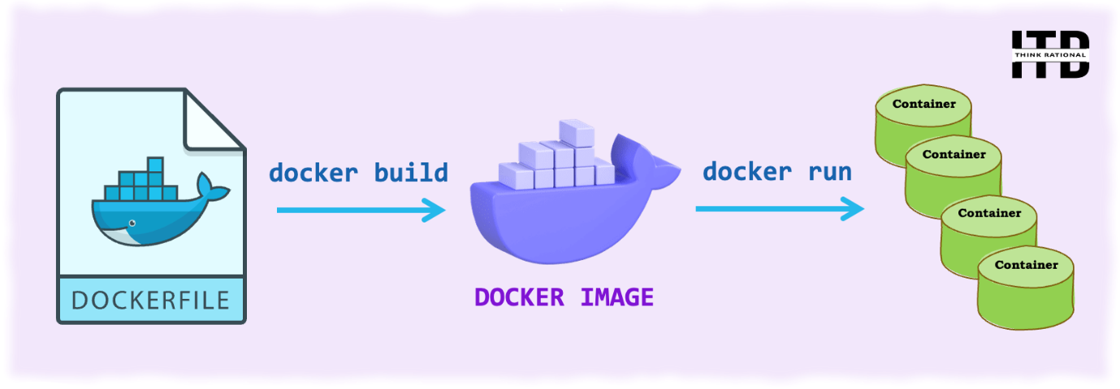      
**Dockerfile**  
        Dockerfile is used to create custom images by using any stock image or other image as base image.  
        In Dockerfile we can write some set of instructions to update any image.  
      
        To create image from Dockerfile  
            docker build -t my_ubuntu .  
**FROM ubuntu**  
        FROM is the first instruction in the every Dockerfile  
        FROM is used to specify the base image on top which all the other   
            instruction will run in the same Dockerfile.  
              
        FROM <image_name>:<tag>  
          
**RUN**  
        Normal shell command or the commands supported by the base image are executed using this instruction.  
        we can have n number of RUN in a single Dockerfile.  
          
        Normal command format   
            RUN <command>

**List only stopped**  
        docker ps --filter "status=exited"

**To stop, start, restart, pause containers**

        docker stop <container_id1> <container_id2> .... <container_idn>  
        docker start <container_id1> <container_id2> .... <container_idn>  
        docker restart <container_id1> <container_id2> .... <container_idn>  
        docker pause <container_id1> <container_id2> .... <container_idn>

**To check the resource utilized by all the container**  
        docker stats           
              
**To list all the process running inside a container**  
        docker top <container_id>

**Container Logs**

* Docker collects logs from containers primarily through its logging drivers.
* When a container generates output to stdout (standard output) and stderr (standard error), Docker captures this output at */var/lib/docker/containers/<container-id>/*
* We can retrieve logs from a running or stopped container using the **docker logs** command

**To fetch the logs generated by a Docker container.**  
        docker logs <container_id>

**To fetch the logs in Real-Time (Follow).**docker logs -f <container_id>

**To fetch the logs with Timestamps.**docker logs --timestamps <container_id>

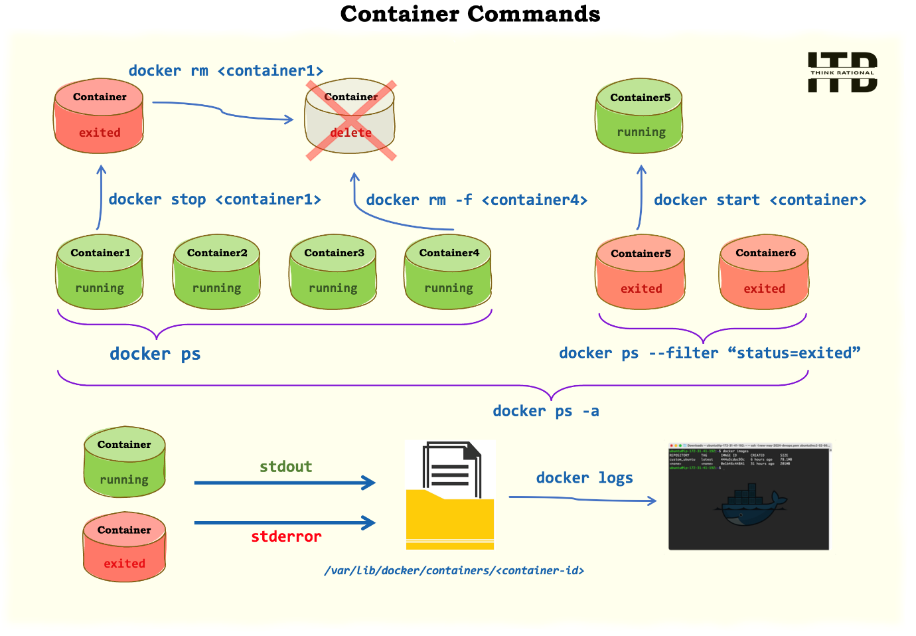

**How to login to a container**  
        **1. To attach to a container**  
            docker attach <container_id>

**To detach from a container**

* press (Ctrl + p) followed by (Ctrl + q).
* This sequence tells Docker to detach from the container without stopping it.
* After detaching, you'll return to your host shell while leaving the container running in the background.

**2. To use exec to create a new shell**  
            docker exec -it <container_id> /bin/bash

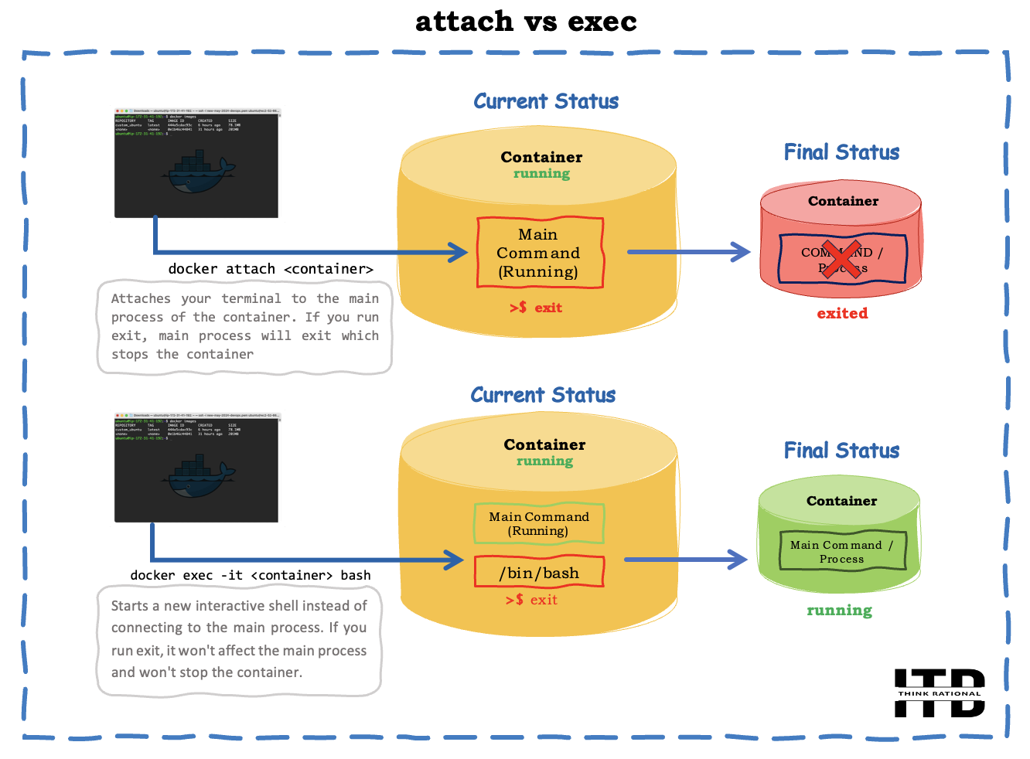

**COPY and ADD**  
        Both copy and add instruction is used to copy files and directories from host machine build location to the image and the container created from it.  
      
**ADD supports extra source formats**

* If the source is a compressed file then ADD will automatically uncompress it in the destination.
* If the source is a downloadable link then ADD will automatically download the file in the destination.

        COPY <source_path_from_build_context> <destination_inside_image>        
        ADD <source_path_from_build_context> <destination_inside_image>





**ENV**

* This instruction is used to set the environment variable inside the container.
* Using this instruction we can create env variables at build time which means in the docker images.

ex:

   1. For individual variable

       ENV <variable_name> <value>

     (OR)

       ENV <variable_name>=<value>

   2. For multiple variable

       ENV <variable_name1>=<value1> <variable_name2>=<value2> .....

**To create environment variables at run time (means in containers)**

1. With the docker run command

    docker run -e <variable_name>=<value> -e <variable_name>=<value>

2. With a list of variables in a file (.env file)

    docker run --env-file <file_path> ...

**CMD vs ENTRYPOINT**

* Both CMD and ENTRYPOINT are used to define the default execution command of the container (the command which will be executed in the container as main process).
* If we use multiple CMD or ENTRYPOINT in the same Dockerfile only the last one will be considered.
* If we use both CMD and ENTRYPOINT in the same Dockerfile, then ENTRYPOINT gets the highest priority and the command defined using CMD will be as parameters to ENTRYPOINT.

CMD ["command","param1","param2",...]

ENTRYPOINT ["command","param1","param2",...]

**Difference**

* CMD can be completely overridden at the runtime (with docker run at the end we can provide the command to override the CMD).
* ENTRYPOINT can't be overridden at the runtime but the command passed at the runtime will become parameters to ENTRYPOINT command defined in Dockerfile.  
            
  Syntax: we can define command in 2 ways   
        1. shell format   
               CMD "ls -lrt"  
            
        2. EXEC format   
  + - * Always first element is command.
      * Except first element all the other elements are parameters to command.

                  CMD ["ls","-lrt"]

**MAINTAINER**

* The MAINTAINER instruction is used to update the Author of the docker images
* The MAINTAINER instruction has been deprecated in favor of using LABEL for metadata since Docker version 1.13. Instead of MAINTAINER

MAINTAINER <Your Name>

(OR)

LABEL maintainer="Your Name <your.email@example.com>"

**USER**

* The USER instruction is used to set the username or UID (User Identifier) for the commands following it in the Dockerfile.
* The USER instruction is used to specify which user the container should run as

USER <username or UID>

**Docker Image Layers  
The order of Dockerfile instructions matters. A Docker build consists of a series of build instructions, each instruction in a Dockerfile translates to an image layer.**

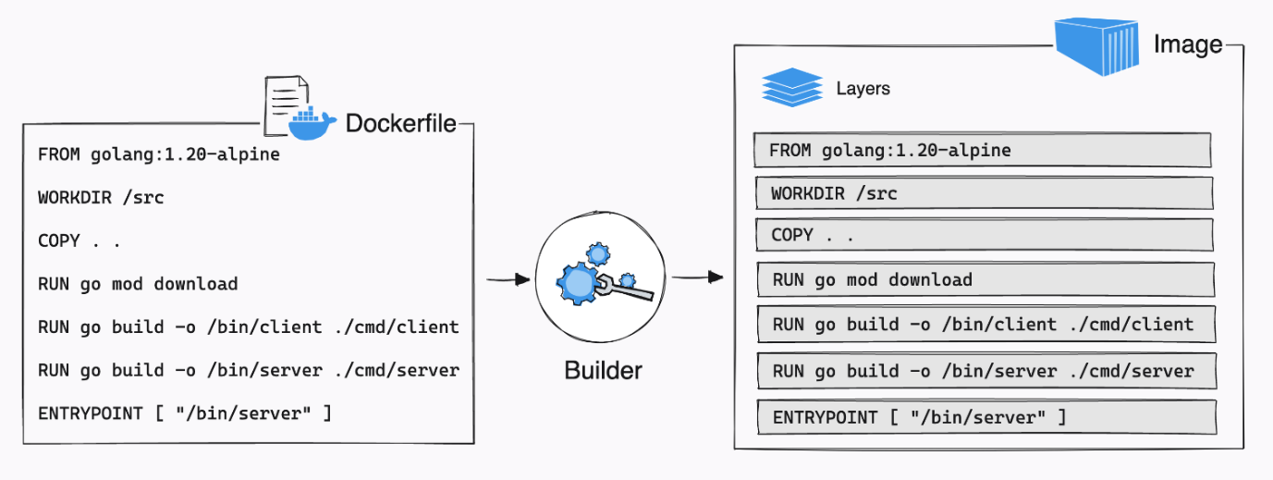

**Cached Layers**

When you run a build, the builder attempts to reuse layers from earlier builds. If a layer of an image is unchanged, then the builder picks it up from the build cache. If a layer has changed since the last build, that layer, and all layers that follow, must be rebuilt.

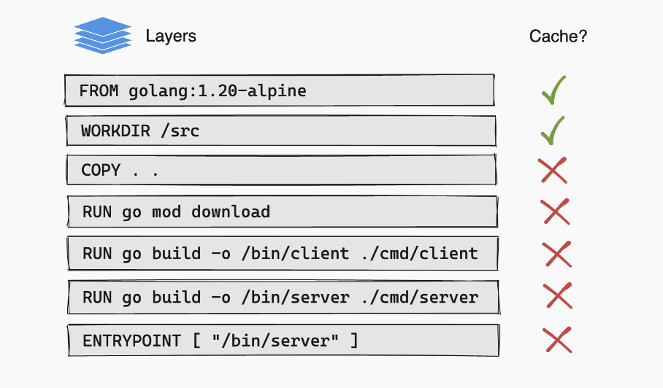

**To wipe the docker builder cache**  
 docker builder prune -af  
  
**To ensure that docker build is completely rebuild (No layers are used from cache)**  
 docker build --no-cache -t my_image:version .  
 **Note:** --no-cache - This will force rebuilding of layers already available in cahce

**Docker volume**

* Docker containers are termed **ephemeral**, meaning data lasts for a short time (ephemeral data). Here in Docker, container data will exist until the container is removed or deleted.
* So volumes are the preferred mechanism for persisting data generated by and used by Docker containers.

**1. Bind mount**

* Bind mounts are dependent on the directory structure of the host machine which are managed by users.
* we mount a host location (file/directory) inside a container location

docker -v <host_path>:<container_path>

* The changes made in host will retain in container and also changes made inside container in this location will retain in host
* If container is deleted host directory will not be deleted (data persistence).
* It is not preferable to mount a single directory to multiple container. (multiple containers processes may try write the data to same file which is not possible)



**Docker Volumes**

* The are docker managed filesystem and we use docker commands to manage these volumes.
* Volumes are easier to manage, backup and migrate than bind mounts.
* We can use different source filesystem called storage drivers (EBS, EFS, s3)
* Default location of docker volume is /var/lib/docker/volumes/<volume_name>

**To create a docker volume**

docker volume create <volume_name>

**To delete volume**

docker volume rm <volume_name>

**To mount a volume**

docker -v <volume_name>:<container_path>

**Benifits of Docker volume over Bind mounts**

* Volumes are easier to back up or migrate than bind mounts.
* You can manage volumes using Docker CLI commands or the Docker API.
* Volumes can be more safely shared among multiple containers.
* Volume drivers let you store volumes on remote hosts or cloud provider storage solutions, encrypt the contents of volumes, or add other functionality.
* Volumes work on both Linux and Windows containers.
* New volumes can have their content pre-populated by a container.
* Volumes on Docker Desktop have much higher performance than bind mounts from Mac and Windows hosts



**Backup a volume content**

1. create a new data volume container

docker run -v /dbdata --name dbstore ubuntu /bin/bash

2. Launch a new container and mount the volume from the dbstore container

   Mount a local host directory as /backup

   Pass a command that tars the contents of the dbdata volume to a backup.tar file inside our /backup directory.

docker run --rm --volumes-from dbstore -v $(pwd):/backup ubuntu tar cvf /backup/backup.tar /dbdata

**Restore from the data volume container backup**

With the backup just created, you can restore it to the same container, or to another container that you created elsewhere.

For example, create a new container named dbstore2:

docker run -v /dbdata --name dbstore2 ubuntu /bin/bash

Then, un-tar the backup file in the new container’s data volume:

docker run --rm --volumes-from dbstore2 -v $(pwd):/backup ubuntu bash -c "cd /dbdata && tar xvf /backup/backup.tar --strip 1"

**Assignment: Mount AWS EFS docker volume to a container.**

docker volume create \

    --driver local \

    --opt type=nfs \

    --opt o=addr=fs-0b0e3aa3ba59955ac.efs.ap-south-1.amazonaws.com,rw,nfsvers=4.1,rsize=1048576,wsize=1048576,hard,timeo=600,retrans=2 \

    --opt device=:/ efs

    To test create a file in the cotnainer

    while true; do echo "Dummy data" >> test.txt; done

**Docker network types**



**1. Bridge**

* This is a private internal network created by docker on the host machine by name docker0
* This is the default network type for all the container which are created without any network configurations.
* By default all the containers in the same bridge can communicate with each other without any extra configuration.
* We cannot use container name for communication only IP address is allowed in default bridge.



**Custom bridge**

To create bridge network

docker network create --driver bridge my_bride

* + In custom bridge containers can communicate with eachother with container name and also with IP address.

**Example:**

bridge      nginx1 - 172.17.0.2  nginx2 - 172.17.0.3

my_bridge   nginx3 - 172.18.0.2  nginx4 - 172.18.0.3

**Check Ping**

    1) Check can we ping by the name

        ping nginx2

    2) Check bridge to bridge communication

        nginx1 -> nginx3 or nginx4

**2. Host**

* This driver removes the network isolation between docker and the host.
* The containers are directly connected to host machine network without extra layer of any docker network.
* Shares the same TCP.IP stack and same namespace of host machine.
* All the network interfaces which are there in host machine are accessible by this container.

**Network Namespace Sharing:** The container shares the same network namespace as the host. It can directly access the network interfaces and services available on the host without any additional isolation.

**Port Binding:** Ports exposed by the container are directly bound to the host's network interfaces. This means that services running within the container can be accessed on the same ports as if they were running on the host.

**Host's IP Address:** The container uses the host's IP address, making it appear as if the container's services are running on the host itself.

**3. None**

* Containers are not attached to any network by docker.
* All the required network configurations need to be done manually.
* The host or any other containers won't be able to communicate with this container until a custom network is configured.

**USE CASE:**

* Running a container for debugging purposes where network access is not needed.
* Creating a container for building or compiling code that doesn't require internet access.
* Running a container that acts as a data volume container, where network communication is unnecessary.

**4. Overlay**

* Overlay networks are meant to define network communication of containers hosted on different host machines.
* To create such a network we use the ‘overlay’ driver.
* The overlay driver is a native driver by docker that helps to create a single layer2 broadcast domain across containers hosted on multiple Docker host machines.

**EXPOSE**  
         Syntax: EXPOSE <port_number>

* Used to expose a port to the docker network so that all the other containers in the same docker network can access it.
* Exposes the port within the host machine.

**Publish**

* Publish will bind the container application port to the host machine port so that
* we can access from the outside world with the host machine port.

Publish = port mapping of container to host machine + Expose

**To publish a port**

docker run -p <host_port>:<container_port>

**To publish all the exposed ports**

docker run -P

-P publish_all, It binds all the exposed ports of the container to the host machine.

**To map a direct IP address to the host**

**port to port**

docker run -p <ip>:<host_port>:<container_port>

**Any to port**

docker run -p <ip>::<container_port>

**Range of ports**

**many to many:**The total number of host ports in the range should be the same as the container port range

docker run -p 8080-8085:8086-8090

**many to one:**This will map to any one of the host ports which is free

docker run -p 8080-8090:8080